**Perfect Instant Pot Eggs**

[](https://soyummy.com/instant-pot-recipes/)

**Ingredients:**

* 12 eggs
* 1 cup water
* Toast, butter, chives, salt and pepper for serving

**Preparation:**

1. Cut your egg carton in half. Stack the two halves on top of each other on the trivet in your Instant Pot.
2. Add 1 cup of water to the inside pot.
3. Seal and Pressure Cook on high for 5 minutes for hard-boiled, 3 minutes for medium jammy yolks and 1 minute for soft-boiled.

<https://soyummy.com/instant-pot-recipes/>

**Instant Pot Cheesecake**

[](https://soyummy.com/instant-pot-recipes/)

*Servings: 6-8*

**Ingredients:**

* 16 ounces cream cheese, room temperature
* ½ cup sugar
* 2 tsp vanilla
* 1/3 cup plain yogurt
* 2 eggs
* 1 ½ cups graham cracker crumbs
* ¼ cup brown sugar, packed
* 7 tbsp unsalted butter, melted
* Cherry topping

**Preparation:**

1. Combine graham cracker crumbs, sugar and melted butter. Then pack into the bottom of a 6 inch springform pan.
2. Cream the cream cheese, sugar and eggs until smooth and lump-free.
3. Add in the vanilla and yogurt and mix to combine.
4. Pour the mixture into the prepared crust.
5. Add 1 cup of water to the inner pot of your instant pot, and add the cheesecake on top of the trivet in the pot.
6. Seal the pot and press Bake, then Cheesecake and cook on high for 37 minutes. Quick release.
7. Remove the cheesecake from the pot and allow to cool completely in the refrigerator.
8. Top with cherry topping.

<https://soyummy.com/instant-pot-recipes/>

**Instant Pot Lava Cakes**

[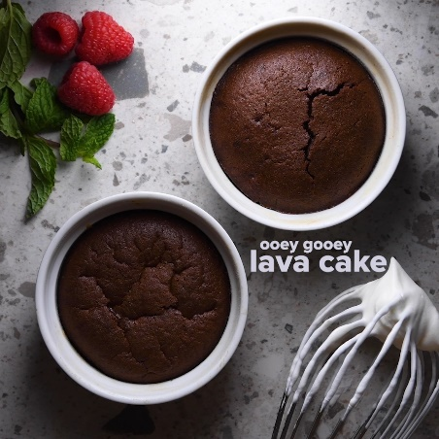](https://soyummy.com/instant-pot-recipes/)

*Servings: 4*

**Ingredients:**

* 2 large eggs
* 2 large egg yolks
* ½ cup unsalted butter
* 1 tablespoon flour
* ¼ cup granulated sugar
* 3.5 – 4 oz dark chocolate
* 1 teaspoon vanilla extract
* ⅛ teaspoon salt
* Berries and whipped cream for serving

**Preparation:**

1. Melt the chocolate and butter in a medium bowl.
2. In a large mixing bowl, add the eggs, egg yolks, granulated sugar, and a pinch of salt. Mix until the batter becomes pale yellow.  
   Add in and stir the chocolate-butter mixture with the egg mixture. Add vanilla extract. Then sift in flour. Mix everything together until everything is well combined.
3. Spray the ramekins with cooking spray. Carefully pour the lava cake batter into four 6-ounce ramekins. Place trivet in Instant Pot, then stack the ramekins on top. Press Bake function and bake on high for 8 minutes.

<https://soyummy.com/instant-pot-recipes/>

**Instant Pot Pad Thai**

[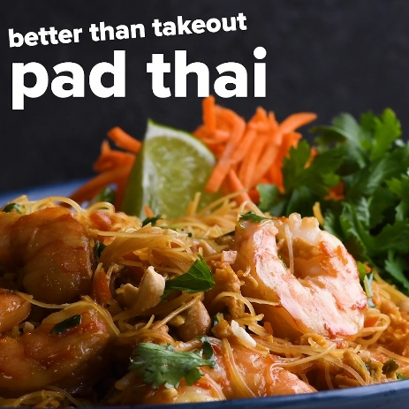](https://soyummy.com/instant-pot-recipes/)

*Servings: 4*

**Ingredients for the sauce:**

* 2 teaspoons soy sauce
* 3 tablespoons fish sauce
* 5 tablespoons brown sugar
* ½ teaspoon tamari paste
* 1 teaspoon rice wine vinegar
* ¼ cup vegetable stock
* ½ teaspoon red pepper flakes

**Ingredients for the Pad Thai:**

* 3 tablespoon vegetable oil
* 1 cup shredded carrots
* ¼ cup chopped green onions
* 2 cloves garlic
* 1 teaspoon minced ginger
* 2 eggs
* ½ pack rice noodles
* ¾ pound raw, peeled shrimp

**Ingredients for garnish:**

* Chopped green onions
* Chopped cilantro
* Chopped peanuts
* Lime juice

**Preparation:**

1. With your Instant Pot set to Saute on low — add the oil, ginger, garlic, green onions and carrots and saute for 3 to 5 minutes until soft.
2. Make a well in the center of the mixture. Add the eggs and scramble quickly. Then mix into the sauteed carrots.
3. Turn off the Saute function. Lay rice noodles on top, add the Pad Thai sauce, and lay the shrimp on top.
4. Pressure Cook on high for 5 minutes.

<https://soyummy.com/instant-pot-recipes/>

**Instant Pot Baby Back Ribs**

[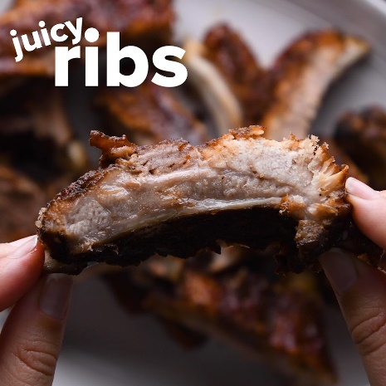](https://soyummy.com/instant-pot-recipes/)

*Servings: 1 Rack*

**Ingredients:**

* 1 tablespoon packed dark brown sugar
* 1 tablespoon dry mustard
* ½ tablespoon paprika
* 1 teaspoon garlic powder
* 1 teaspoon onion powder
* 1 teaspoon Chinese five spice
* 1 teaspoon salt
* 1 teaspoon coarsely ground black pepper
* 1/2 teaspoon chili powder
* 1 rack baby back ribs
* 1 cup water
* Optional: 1 cup barbecue sauce

**Preparation:**

1. Mix all spices together and season the rack of ribs, front and back.
2. Add the trivet and 1 cup of water to the inner pot of your Instant Pot.
3. Roll the ribs up into one coil, and place the coil on the trivet in your pot.
4. Seal your Instant Pot and Pressure Cook on high for 25 minutes, then quick release.
5. Optional: Brown the ribs on a baking sheet in the oven set to broil for 5 minutes. Barbecue sauce may be added for extra sauciness.

<https://soyummy.com/instant-pot-recipes/>

**Instant Pot Bread**

[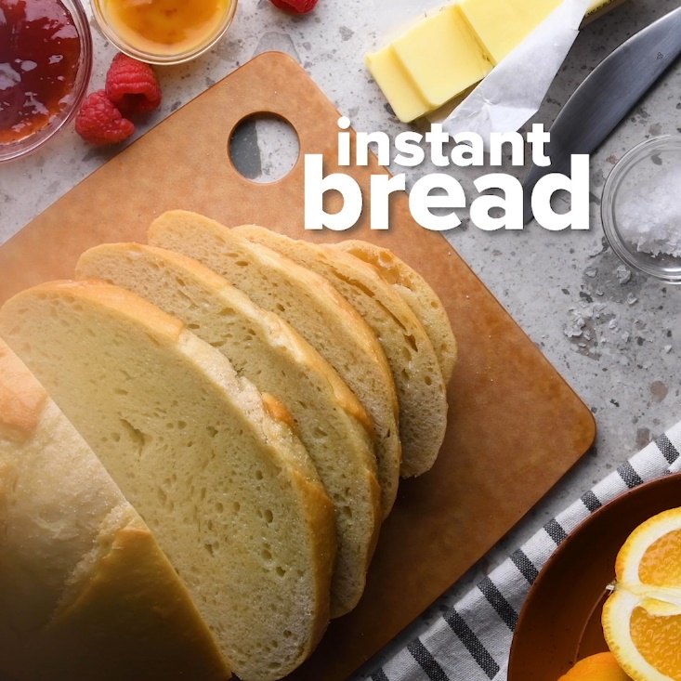](https://soyummy.com/instant-pot-recipes/)

*Servings: 1 Loaf*

**Ingredients:**

* 1 cup warm water
* 1 1/4 teaspoons yeast
* 1/2 tablespoon salt
* 2 1/4 cups all purpose flour

**Preparation:**

1. In a large bowl, combine water, yeast and salt. Let the yeast proof for about 3 minutes, then start adding in the flour.
2. Mix the dough by hand until all the elements have combined and you have no loose flour. No need to knead.
3. Place the dough in a greased, 6 inch cake pan.
4. Add the pan to your Instant Pot, seal the lid and Proof at 80°F for 1 hour. The dough will double in size.
5. Bake on high for 45 minutes.

<https://soyummy.com/instant-pot-recipes/>

**Instant Pot DIY Extracts**

[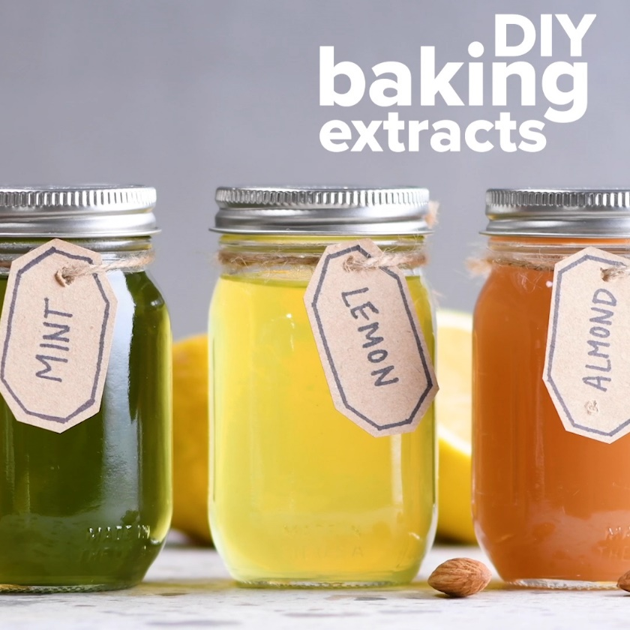](https://soyummy.com/instant-pot-recipes/)

**Ingredients:**

* ½ cup almonds
* 2 vanilla beans
* Peel of 1 lemon
* Handful of mint
* Bottle of vodka
* 1 cup water

**Preparation:**

1. Fill four medium-sized, heat-proof mason jars with mint, almonds, lemon peel and vanilla beans, respectively.
2. Add vodka to each jar until ¾ of the way full, and seal the jars very loosely.
3. With the trivet inside the Instant Pot, add your four jars. Then add 1 cup of water to the inner pot.
4. Seal the pot in Pressure Cook on high for 30 minutes, then quick release.
5. Allow the extracts to sit for 2 weeks, then use or gift!

<https://soyummy.com/instant-pot-recipes/>